\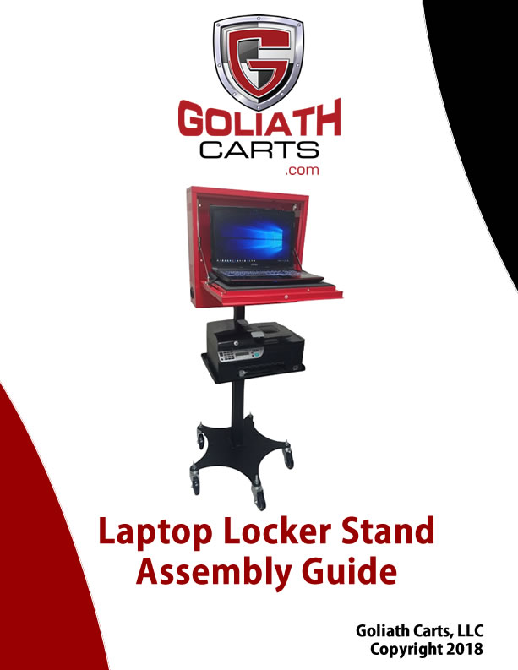

CK-100 CHECK-IN KIOSK ASSEMBLY INSTRUCTIONS
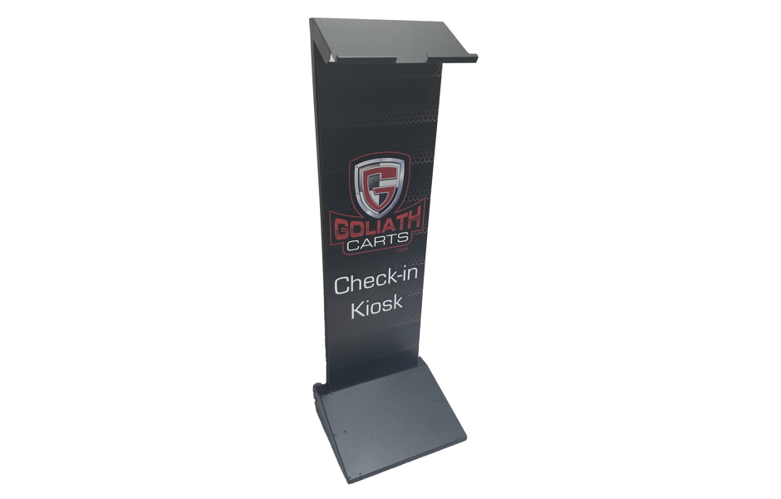
GOLIATH CK-100 CHECK-IN KIOSK SAFETY INSTRUCTIONS
Please read completely before using the Cart.

Follow the information warnings written on the sticker affixed to the door paper areas. Do not remove warning label from the cart.
Always use the recommended equipment to prevent damage or failure.
Do not allow children under the age of 18 years of age to use the cart.
Do not use the cart for any other purposes than what is described in our manuals and web site.
Do not use substitute parts. Contact the manufacturer or Goliath Carts for replacement parts.

This product is manufactured by Goliath Carts, LLC.
P.O. Box 891210
Temecula, CA 92589
Toll Free: 866.694.2278
GOLIATH CK-100 CHECK-IN KIOSK ASSEMBLY INSTRUCTIONS
with BRANDING (OPTIONAL)

Part # | Qty | Description
A | 12 | ¼-20 X 1” Screw, Washer and Lock Washer- Black Anodized
B | 2 | Caster Base
C | 1 | Caster Base Connector Plate
D | 5 | 7/16-14 Nut, Washer, and Locking Washer
E | 3 | Swivel Casters
F | 2 | Locking Casters
G | 1 | Bottom Stanchion
H | 1 | Upper Stanchion with Mounting Plate
I | 1 | Red T-Handle
J | 4 | ¼-20 X ½” Screw, Washer, and Lock Washer – Black Anodized
K | Optional | Printer Shelf
L | Optional | Printer Shelf Mounting Bracket
M | 1 | Allen Key

PLEASE NOTE: THIS STAND IS DESIGNED TO BE ASSEMBLED USING THE ALLEN WRENCHES PROVIDED.
DO NOT USE POWER TOOLS TO ASSEMBLE THE CART AS IT MAY DAMAGE THE PRODUCT.

Tools Needed:

- 5/16 Socket for installing casters and holding bolts during install
- Allen Wrenches (included)
Base Installation Points

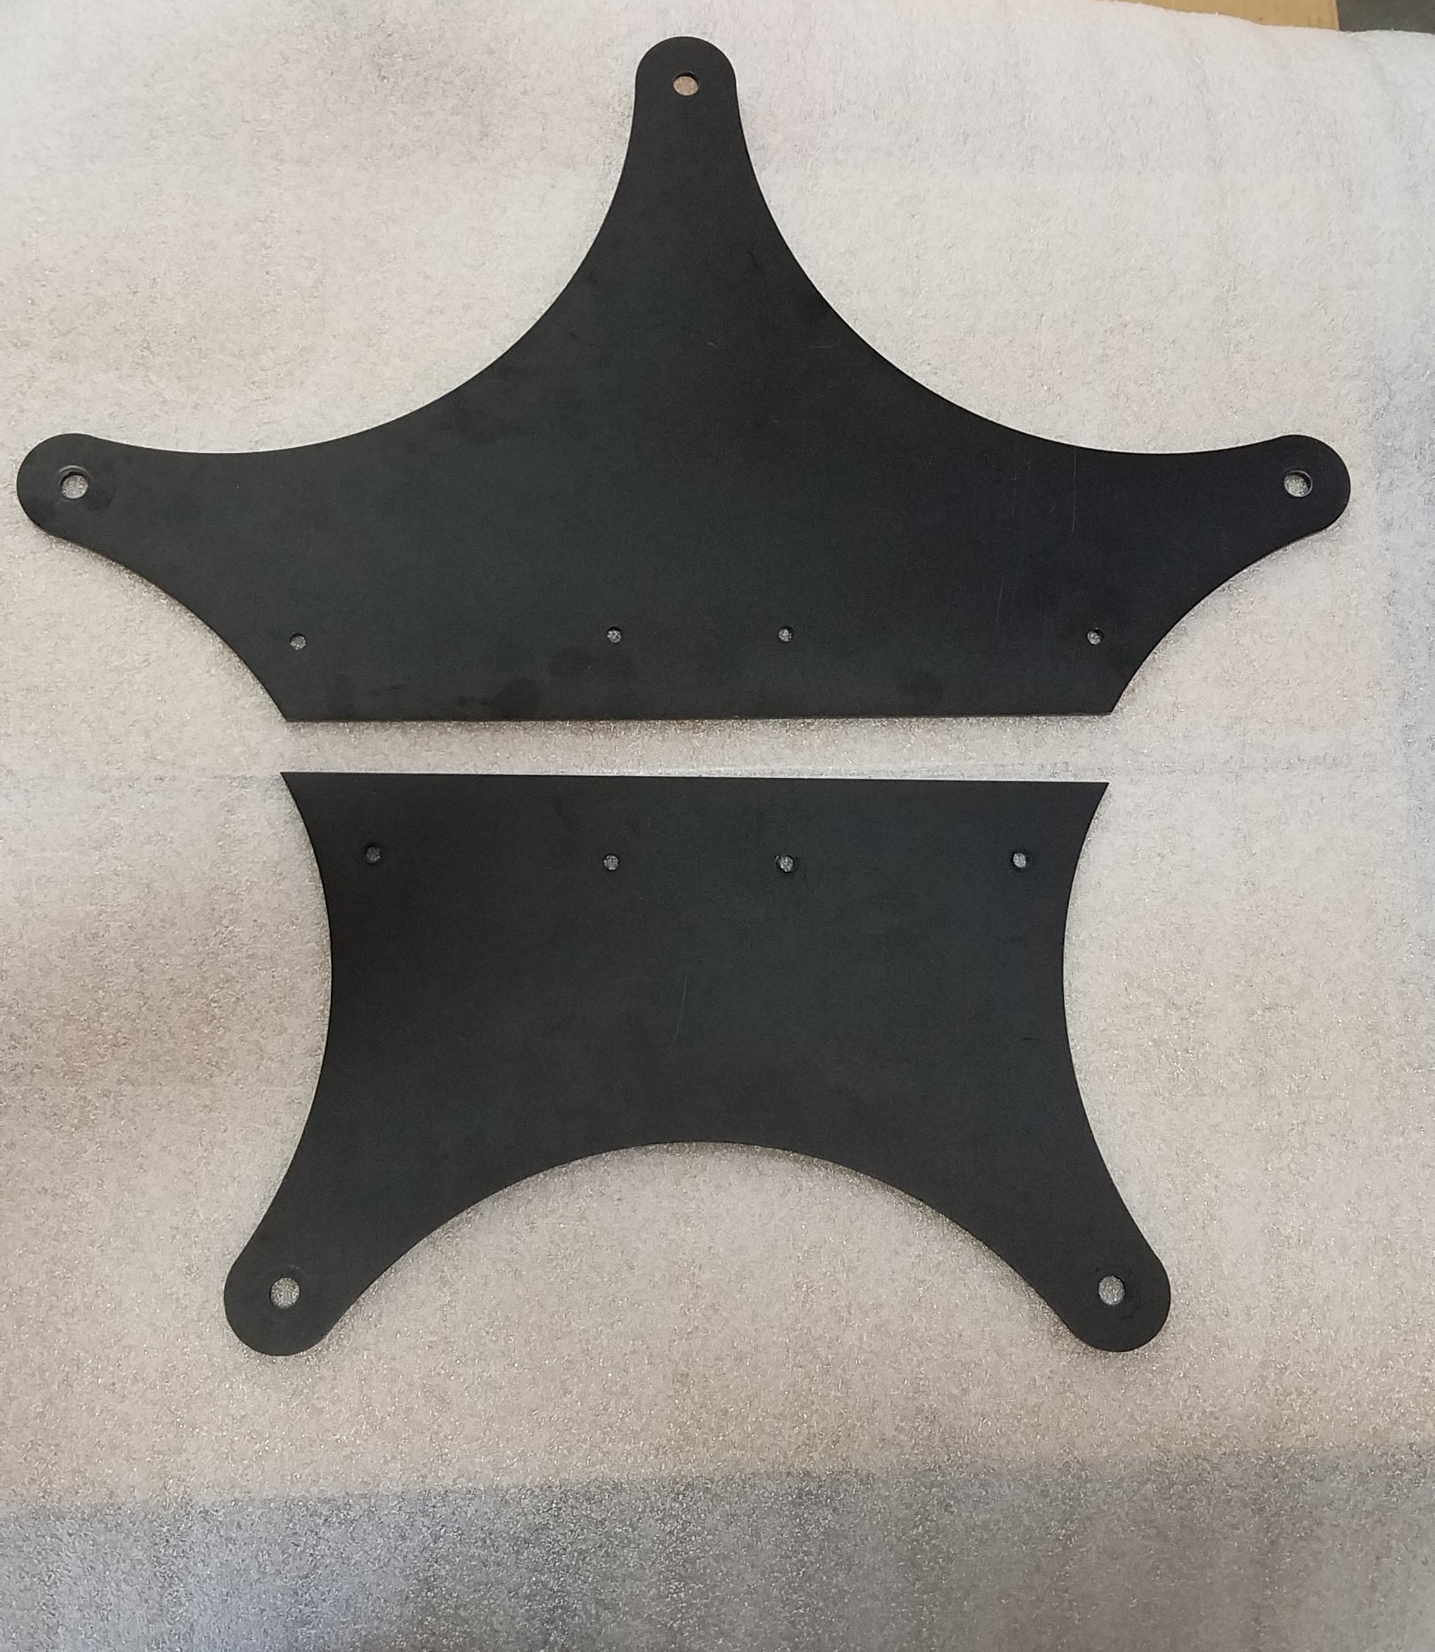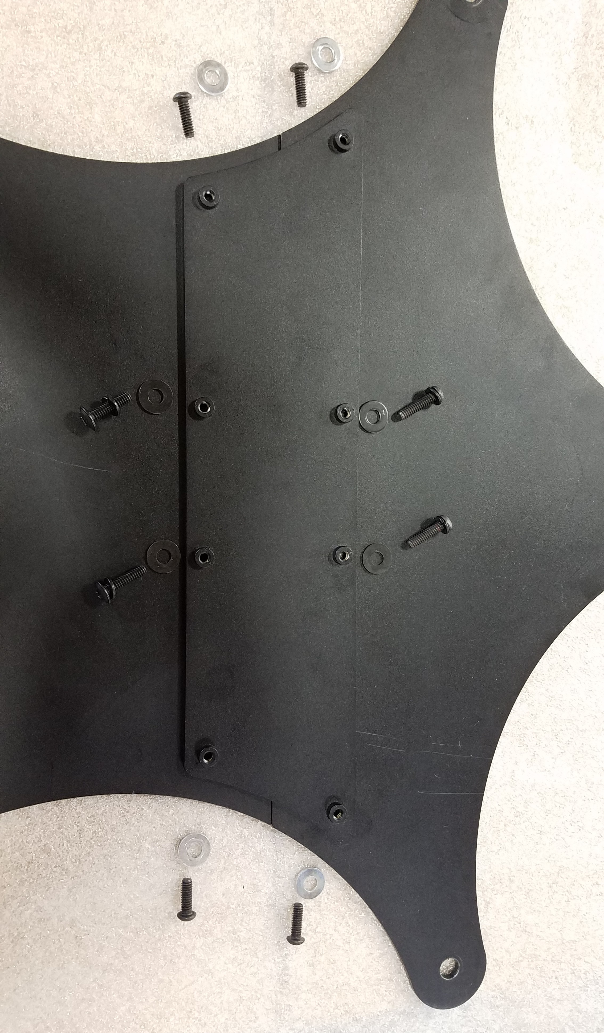

STEP 1: Assemble the Caster Base and Caster Base Connector Plate

- Lay the 2 - Caster Base down (Part B). Secure together using the Caster Base Connector Plate (Part C) with (4) ¼ -20 X 1” black anodized screws and washers (Part A). Note: Only Secure the 4 outside connections above.
- Install 3 Swivel Casters (Part E) and 2 Locking Swivel Casters (Part F) on each point of the base using 5 – 7/16-14 nut, washers and lock washers (Part D).

STEP 2:
- Place Bottom Stanchion (Part G) on top of base you just assembled, using (4) – ¼ - 20 X 1” screws, washers and locking washers (Part A).
- Attach Goliath Laptop Locker to Upper Stanchion w/ Mounting Plate (Part H) using (4) – ¼ - 20 X 1/2” screws, washers and locking washers (Part J)
- Slide assembled Upper Stanchion (Part H) into Bottom Stanchion (Part G).
- Secure the posts together using the T-handle (Part I) at desired height.

STEP 3: Printer Shelf (Part L1A-PS) - Optional

- Affix the Printer Shelf (Part K), around the post with the Printer Shelf Mounting Bracket (Part L), with (4) ¼-20 X ½” – screws and washers (Part J).

CK-100 CHECK-IN KIOSK INSTALLATION IS COMPLETE.
PLEASE REVIEW ALL SAFETY INSTRUCTIONS
We have FAQ’s and Technical Documents on our website
Visit us online at www.goliathcarts.com

